**Project Design Phase-II Technology Stack (Architecture & Stack)**

|  |  |
| --- | --- |
| Date | 15 October 2022 |
| Team ID | PNT2022TMID40524 |
| Project Name | Analytics in Hospital Health Care Data |
| Maximum Marks | 4 Marks |

Technical Architecture:

The Deliverable shall include the architectural diagram as below and the information as per the table1 & table 2

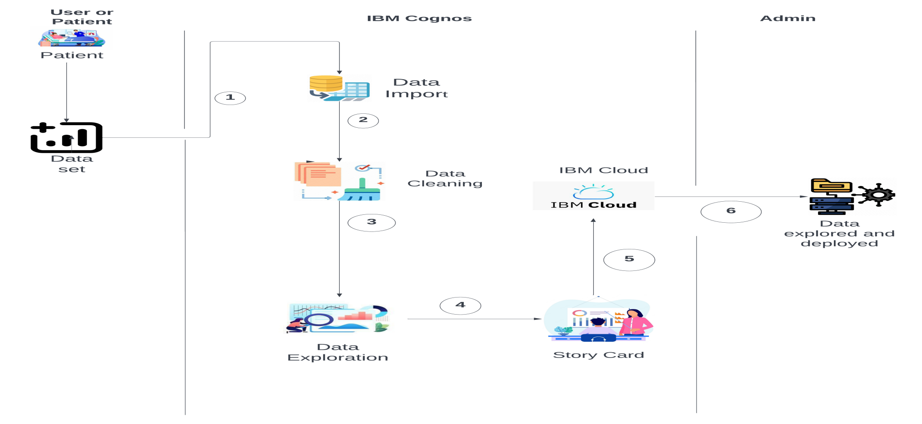

Table-1 : Components & Technologies:

|  |  |  |  |
| --- | --- | --- | --- |
| **S.No** | **Component** | **Description** | **Technology** |
| 1. | User Interface | How user interacts with application e.g. Web UI, Mobile App, Chatbot etc. | IBM Cognos / Python . |
| 2. | Data Set | The data set prepared for hospitals health care | Python . |
| 3. | IBM Cognos | Data analytics platform | IBM Watson service |
| 4. | Data Import | Data set is imported in IBM cognos | IBM Watson Assistant |
| 5. | Data Cleaning | Data is cleaned by using some mathematical techniques such as mean,mode etc.to clean the null and missing data. | IBM Assistant |
| 6. | Data Exploration | Cleaned data can be explored. | IBM Cognos |
| 7. | Story Card | Data is explored and story card was prepared for visual representation | IBM Cognos |
| 8. | IBM Cloud | Storage of data | IBM DB2 |
| 9. | Data Explored and Deployed | Purpose of External API to explored and deployed | Data deployed to user by UI |
| 10. | Admin | Purpose of Data set model | Recognition of data set model etc. |

Table-2: Application Characteristics:

|  |  |  |  |
| --- | --- | --- | --- |
| **S.No** | **Characteristics** | **Description** | **Technology** |
| 1. | Open-Source | Open source model is used for the data set | Python |
| 2. | Security Implementations | Security for our data set | SHA 256, SHA 1 |
| 3. | Scalable Architecture | health care service utilizes the relational patient data and big data analytics to tailor the medication recommendations | Python |

|  |  |  |  |
| --- | --- | --- | --- |
| **S.No** | **Characteristics** | **Description** | **Technology** |
| 4. | Availability | The availability of technology used in data analytics | Python-Anaconda distribution and jupyter notebook is available and open source application |
| 5. | Performance | The performance of the application and its efficiency | Python and other languages is that Python is usually interpreted. Interpreted languages tend to perform worse than compiled languages, each command takes up a greater number of machine instructions . |